**Project 3: Texture Mapping**

**Screenshots**

1)No Texture

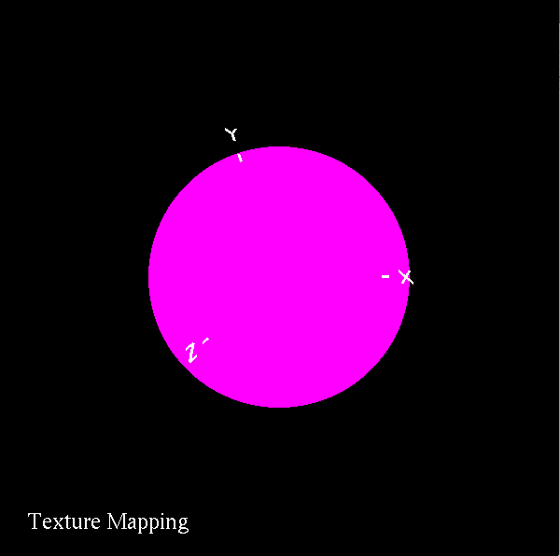

2)Texture

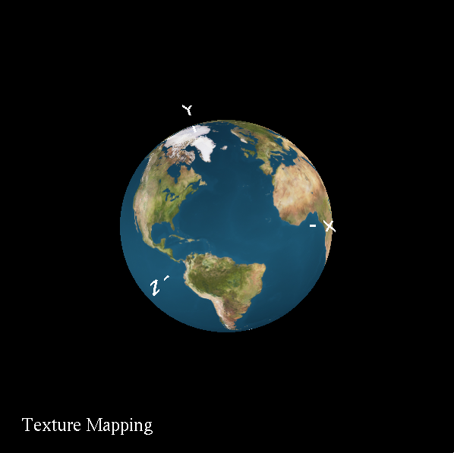

3)Distortion

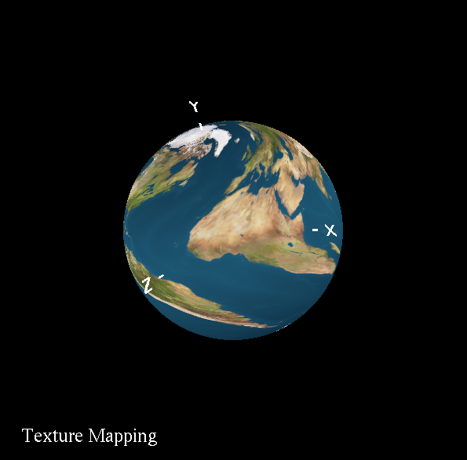

**Youtube Video Link:**

<https://youtu.be/3GFGljYomzY>